

CS-250 : Lab 02
Dynamic Memory Allocation with Git and Unit Testing

Muhammad Mujtaba
CMD ID: 540040
mmujtaba.bese25seecs@seecs.edu.pk

  - Class: BESE 16B
  - Batch: 2k25

Task 1:
I. Creating a GitHub Account:
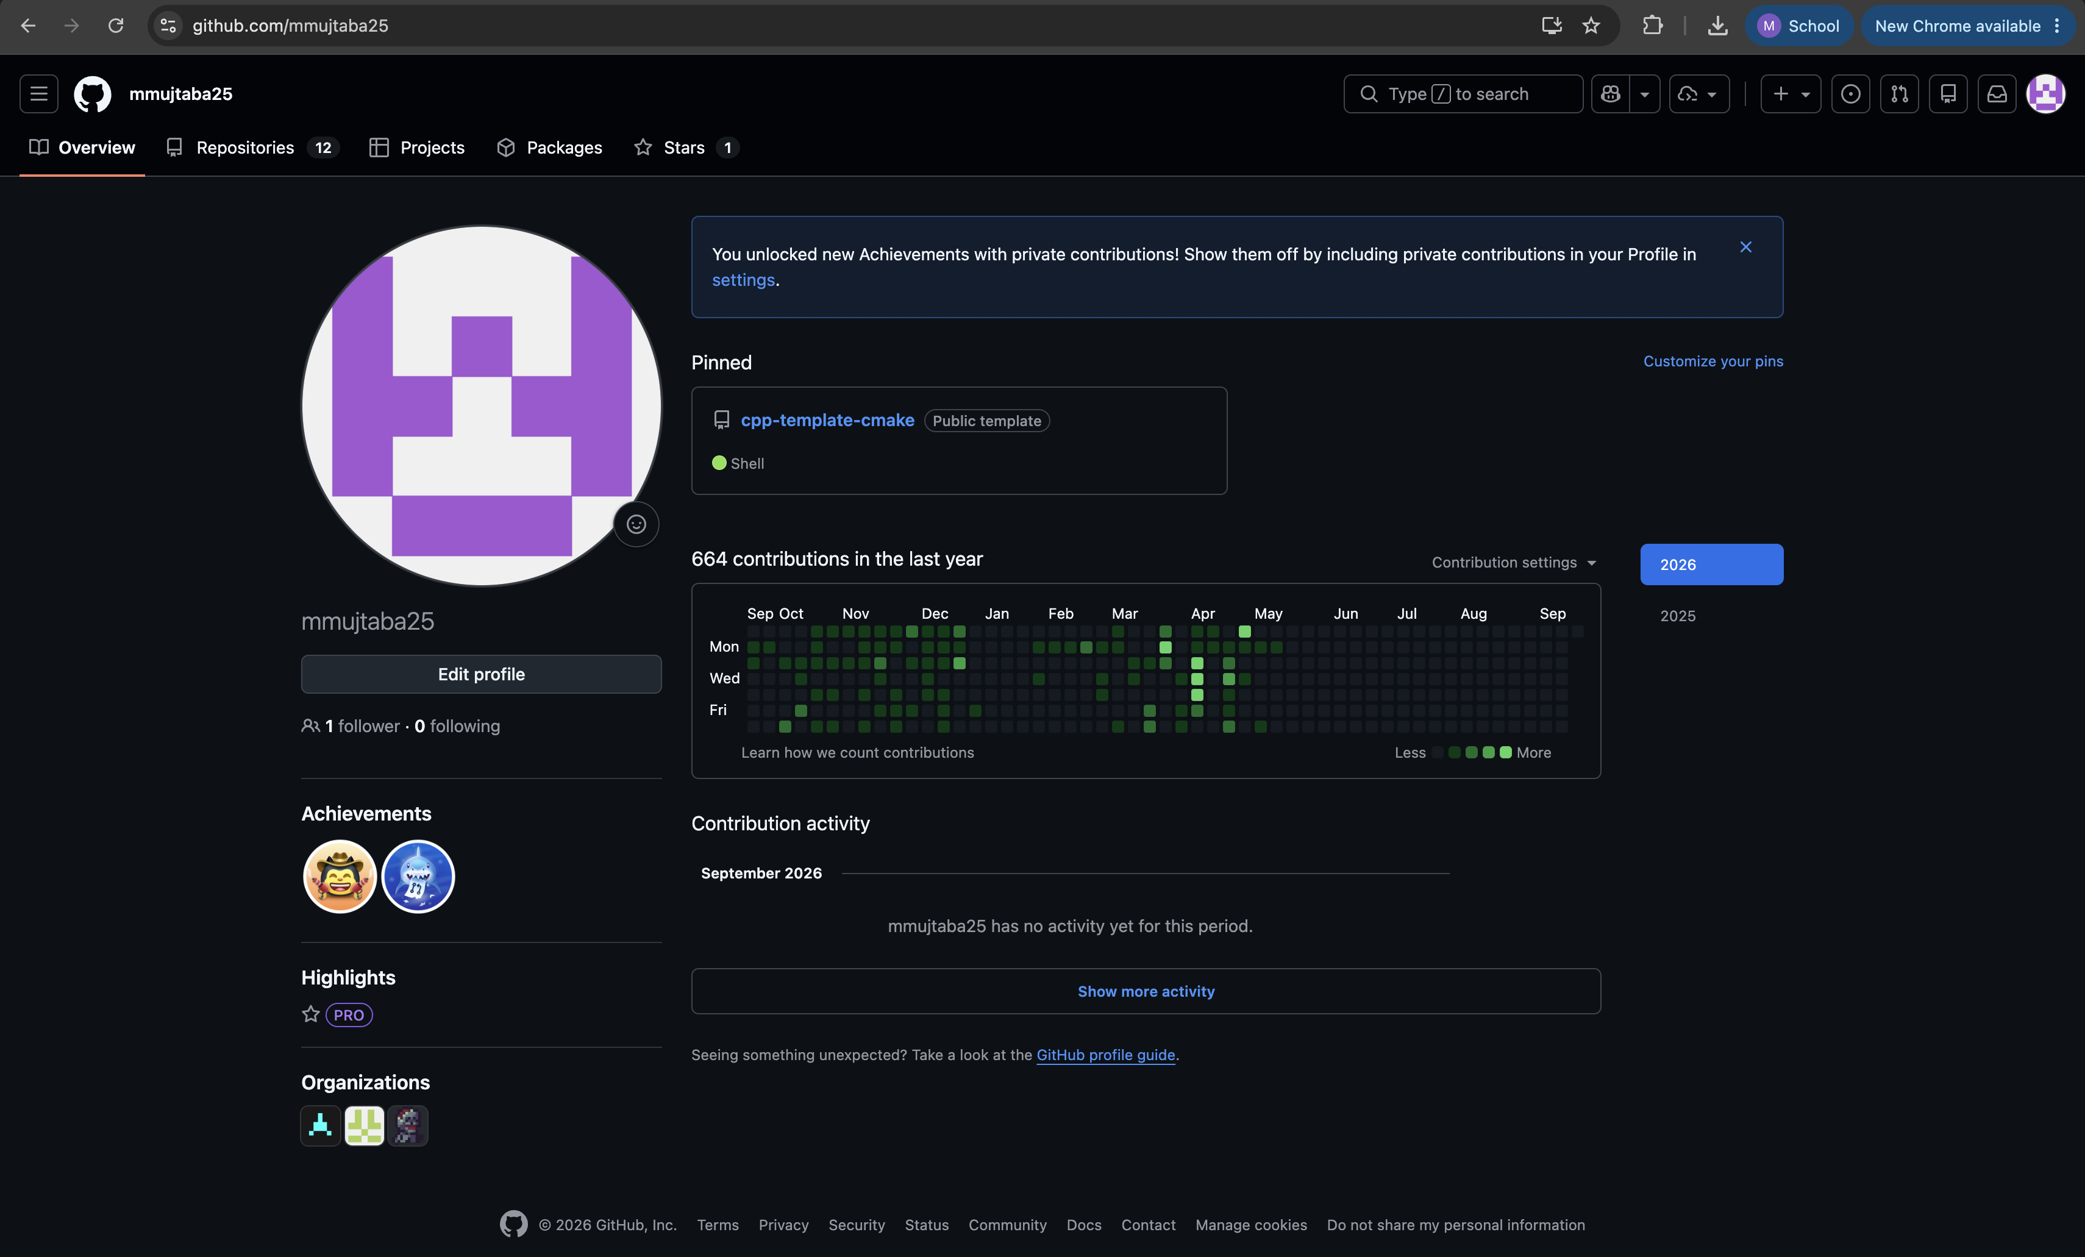
Link: https://github.com/mmujtaba25
II. Create a New Repository:
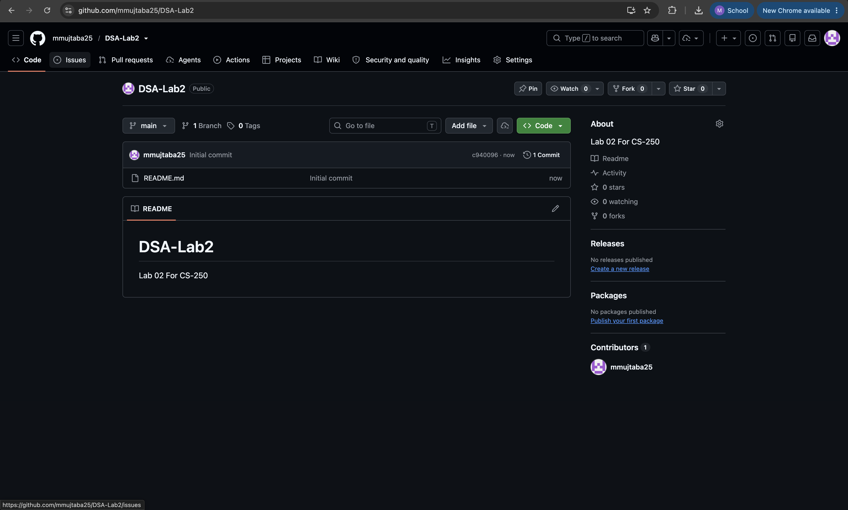
Link: https://github.com/mmujtaba25/DSA-Lab2
III. Clone Repository to Local Machine:
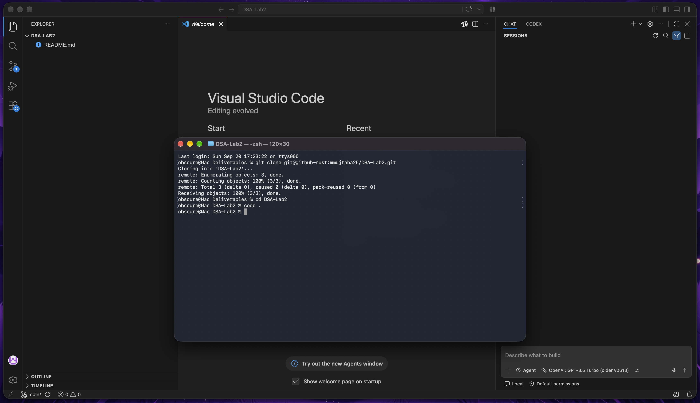
IV. Set Git Identity:
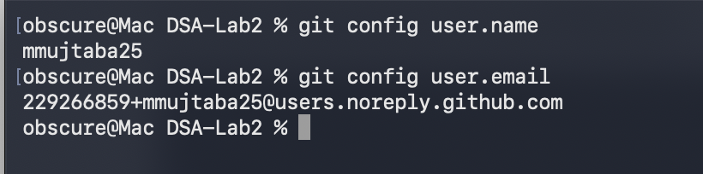
V. Add a Starter Program:
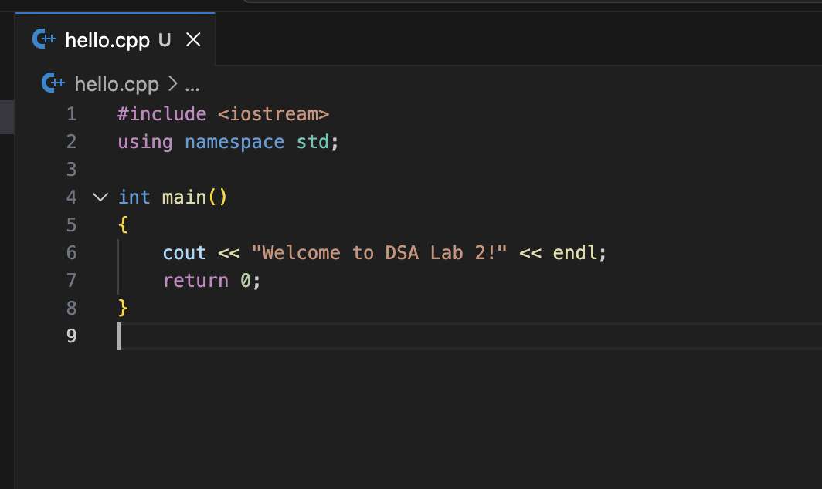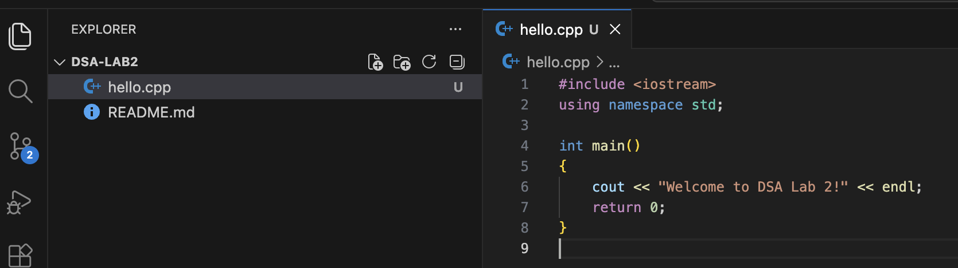

VI. Build and Run:
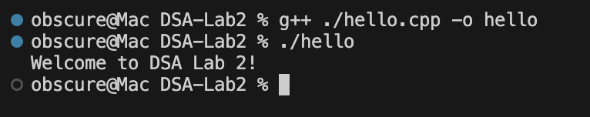
VII. Stage, Commit, and Push:
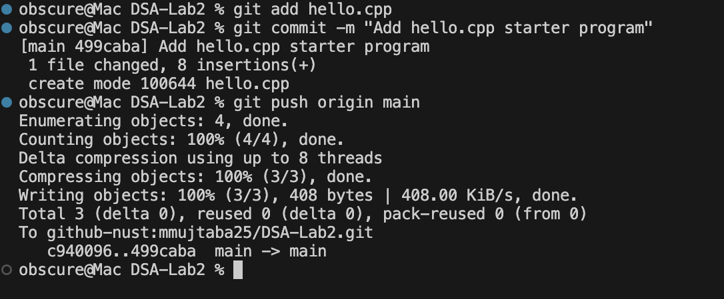

Task 2:
Updated Program Committed on Git:
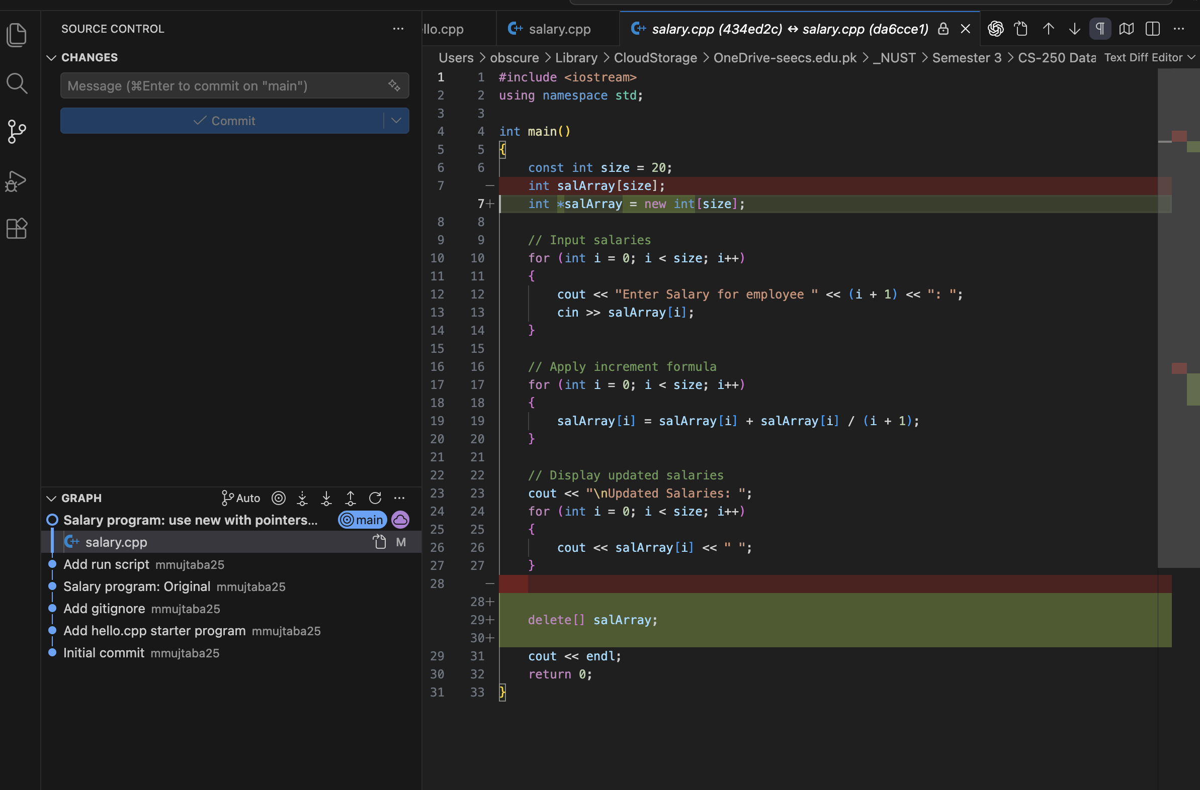
Link: https://github.com/mmujtaba25/DSA-Lab2/commit/da6cce1b18a5746b91767e22b993613aefb6a4a0

Task 3:
#include <iostream>

void analyze_pointer(int *ptr)
{
std::cout << ptr << " : " << *ptr << "\n";
}

int main()
{
int stackInt = 5;
analyze_pointer(&stackInt);

int *heapInt = new int;
*heapInt = 10;
analyze_pointer(heapInt);
delete heapInt;

return 0;
}

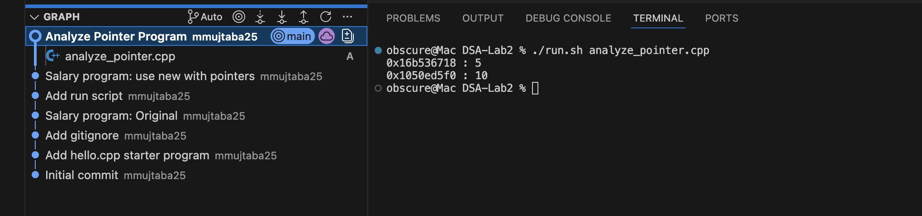

Task 4:
#include <iostream>
#include <string>

constexpr int DEBUG = false;

namespace util
{
void swap(char &a, char &b);
int floor(double value);
void debug_print(const char c);
void debug_print(const char *str, int size);
}

void reverse_string(char *str, const int size);
void reverse_string_raw(char *str, const int size);

int main()
{
constexpr int SIZE = DEBUG ? 11 : 51; // one extra for NULL byte
char *str = new char[SIZE];

std::cout << "Enter a string (max " << SIZE - 1 << " chars): ";
std::cin.getline(str, SIZE);

reverse_string(str, SIZE);

std::cout << "Your string is reverse is: " << str << "\n\n";
delete[] str;

return 0;
}

namespace util
{
void swap(char &a, char &b)
{
a = a ^ b;
b = a ^ b;
a = a ^ b;
}

int floor(double value) { return (int)value; }

void debug_print(const char c)
{
if (!DEBUG)
return;

// print ":" for NULL byte
if (c == '\0')
std::cout << ":";

std::cout << c;
}

void debug_print(const char *str, int size)
{
if (!DEBUG)
return;

for (size_t i = 0; i < size; i++)
debug_print(str[i]);

std::cout << "\n";
}
}
void reverse_string_raw(char *str, const int size)
{
util::debug_print(str, size);

if (DEBUG)
std::cout << "\n:MIRRORING: \n\n";

// mirror string
for (size_t i = 0; i < util::floor(size / 2); i++)
{
util::swap(str[i], str[size - i - 1]);
util::debug_print(str, size);
}
}

void reverse_string(char *str, const int size)
{
reverse_string_raw(str, size);

// get first null character from the right
// first null from right is where cout terminates
int null_at = 0;
for (int i = size - 1; i >= 0; i--)
{
if (str[i] == '\0')
{
null_at = i + 1;
break;
}
}

if (DEBUG)
std::cout << "\n:OFFSETTING: \n\n";
util::debug_print(str, size);

// move string so str[0] is the last character before first character
for (size_t i = 0; i < (size - null_at); i++)
{
util::swap(str[i], str[i + null_at]);
util::debug_print(str, size);
}

// append NULL at string end (before str[0] in original string)
str[size - null_at] = '\0';

util::debug_print(str, size);
}

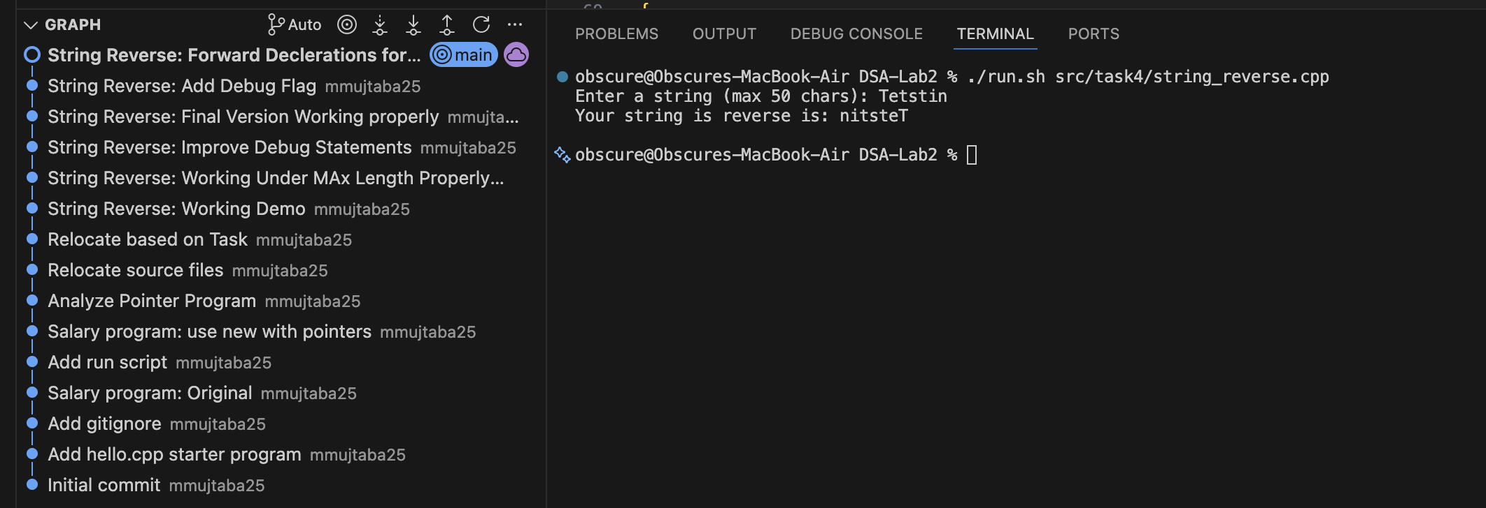
Link: https://github.com/mmujtaba25/DSA-Lab2/blob/main/src/task4/string_reverse.cpp

Task 5:
I. Write the Tests First:
void testSortedArray()
{
int arr[] = {1, 2, 3, 4, 5};
assert(isSorted(arr, 5) == true);
}

void testUnsortedArray()
{
int arr[] = {4, 5, 2, 3, 1};
assert(isSorted(arr, 5) == false);
}

void testDuplicateValues()
{
int arr[] = {1, 2, 3, 4, 4};
assert(isSorted(arr, 5) == true);
}

void testSingleElement()
{
int arr[] = {1};
assert(isSorted(arr, 1) == true);
}

void testDescendingArray()
{
int arr[] = {5, 4, 3, 2, 1};
assert(isSorted(arr, 5) == false);
}

void testNegativeValues()
{
int arr[] = {-5, -4, -3, -2, -1};
assert(isSorted(arr, 5) == true);
}

void testAllSameValues()
{
int arr[] = {1, 1, 1, 1, 1};
assert(isSorted(arr, 5) == true);
}

void testEmptyArray()
{
assert(isSorted({}, 0) == true);
}

II. Implement the Function:
bool isSorted(const int *arr, const int size)
{
if (size == 0)
return true;

for (size_t i = 0; i < size - 1; i++)
{
if (arr[i] > arr[i + 1])
{
return false;
}
}

return true;
}

III. Demonstrate the TDD Cycle:
Test for Empty Array Failing (the function fails before result can reach assert function)
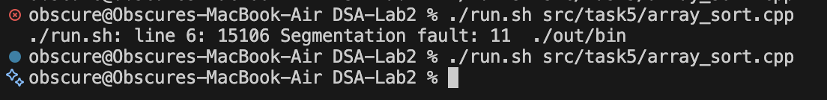
Before and After Commit “Array Sort: testEmptyArray Pass”
Link: https://github.com/mmujtaba25/DSA-Lab2/commit/95302ebeab9bd7e7ac9ab50dcbb2ab18889c0892
IV. Git Workflow:
Tests were written in Commit Named “Array Sort: Write Tests”
Link: https://github.com/mmujtaba25/DSA-Lab2/commit/5a664e6b5d298f0bf58984835659b9ef01791540
